The ESP8266_Webserver project.

This project Contains the following (I think) unique functions that deserve to be talked about.
- Full FAT32 functionality using an SD card which is driven natively by the HSPI port on the ESP8266. All of the functionality runs efficiently enough to keep within the constraints of the watchdog timer. This is not trivial and tookl a lot of time and energy to accomplish.
- The system supports uploading and downloading files to and from the SD card via a web browser, using the “Upload.htm” and “listdir.htm” web pages.
- You can upload and download up to 3 files simultaneously.
- There is a routine for getting the time from the web, and when a connection is not available, time is kept internally.
- The project was developed in Visual Studio community edition. The complete project is here in the ESP8266 software.zip.
- Download the zip file and expand it. Copy the folders called esp8266_webserver, espressif and minGW to your “C:\” drive.
- Copy the contents of the SD card contents file to your SD card.
- Start Visual studio and open a project. Go to c:\esp8266_webserver\ESP8266_WEBSERVER.sln. The project should open in Visual studio.
- Build the project. Once it builds, you will have a folder called firmware that contains 2 files. 0x00000.bin and 0x40000.bin.
- Use the NodeMCU programmer to flash your Board.
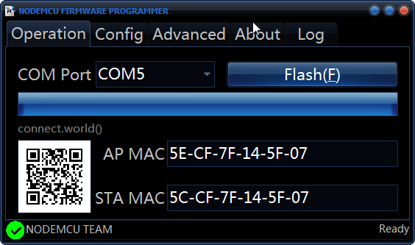
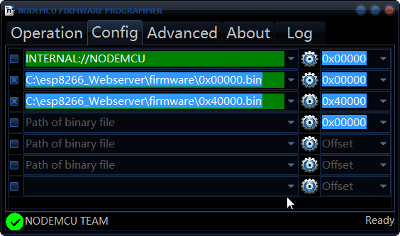

Put the filenames in the config section like this.

- On the SD card there is a file called esp8266.ini. This holds the initial values that you can configure to get stared. See below. Put your router SSID and password in.
- Place the card in your board and reboot the ESP8266. It should connect to your network with a static IP address of 192.168.1.60 (see the “staticip” property in the ini file below).
- You can now navigate to the IP address in your browser 192.168.1.60/upload.htm and you should be presented with the upload page.
- You can also go to 192.168.1.60/listdir.htm and see the contents of the disk. You can download files from here, or delete them if they are no longer needed.
- You can now upload any web page to the disk and it will work in the browser.

